Ideation Phase

Empathize & Discover

Date: 20 February 2026
Team ID: LTVIP2026TMIDS70508
Project Name: Learn Hub – Online Learning Platform
Maximum Marks: 4 Marks
Empathy Map Canvas:
An empathy map is a simple visual tool that captures knowledge about a user’s behaviors, thoughts, feelings, and challenges. It helps the team better understand the user perspective before designing the solution.
Reference: https://www.mural.co/templates/empathy-map-canvas

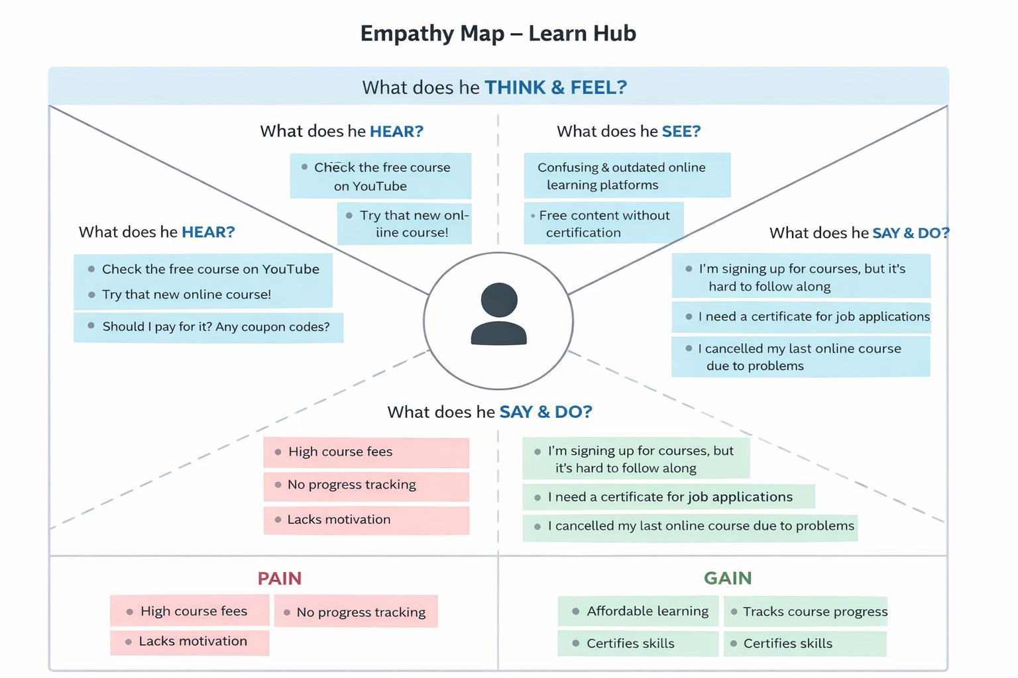

Empathy Map – Target User: Student

1. What does the user THINK & FEEL?
• Wants to improve skills and get certified.
• Worried about affordability of courses.
• Concerned about course quality.
• Motivated to build career opportunities.

2. What does the user SEE?
• Many online learning platforms.
• Expensive subscription models.
• Unstructured or outdated courses.
• Advertisements promising quick results.

3. What does the user HEAR?
• Friends recommending certain platforms.
• Influencers promoting paid courses.
• Educators suggesting skill-based learning.
• Employers demanding certifications.

4. What does the user SAY & DO?
• Searches for affordable courses online.
• Compares course ratings and reviews.
• Watches demo videos before enrolling.
• Tracks progress and downloads certificates.

5. PAIN Points
• High course fees.
• Lack of structured learning paths.
• No proper progress tracking.
• Limited access to quality instructors.

6. GAIN Points
• Affordable and accessible learning.
• Structured course modules.
• Progress tracking with completion percentage.
• Downloadable certificate after completion.
• User-friendly dashboard.

Conclusion
Based on the empathy analysis, Learn Hub is designed to provide structured, affordable, and user-friendly online learning with progress tracking and certificate generation to improve student satisfaction and career growth.

